**DAILY ONLINE ACTIVITIES SUMMARY**

|  |  |  |  |  |  |  |  |  |
| --- | --- | --- | --- | --- | --- | --- | --- | --- |
| **Date:** | **10/08/2020** | | | | | **Name:** | **Spoorthy Balaji** | |
| **Sem & Sec** | **6th & B** | | | | | **USN:** | **4al17cs098** | |
| **Online Test Summary** | | | | | | | | |
| **Subject** | | **-** | | | | | | |
| **Max. Marks** | | **-** | | **Score** | | | **-** | |
| **Certification Course Summary** | | | | | | | | |
| **Course** | **Salesforce Trailhead** | | | | | | | |
| **Certificate Provider** | | | **-** | | **Duration** | | | **-** |
| **Coding Challenges** | | | | | | | | |
| **Problem Statement: Check whether a number has consecutive 0’s in the given base or not** | | | | | | | | |
| **Status: Solved** | | | | | | | | |
| **Uploaded the report in Github** | | | | | **yes** | | | |
| **If yes Repository name** | | | | | <https://github.com/spoorthybalaji/Daily_Status> | | | |
| **Uploaded the report in slack** | | | | | **yes** | | | |

**ONLINE COURSE**

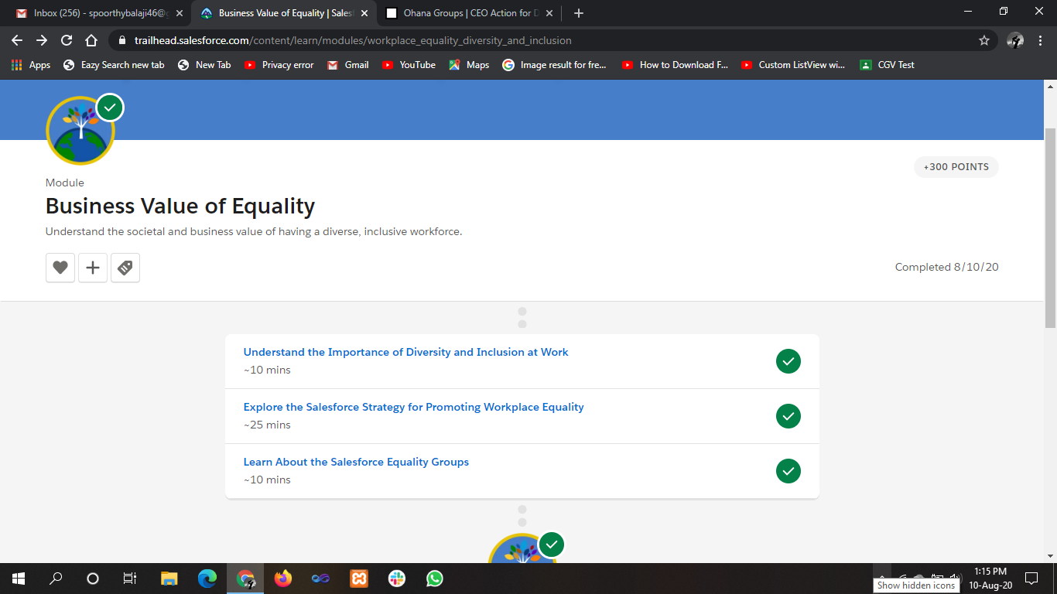

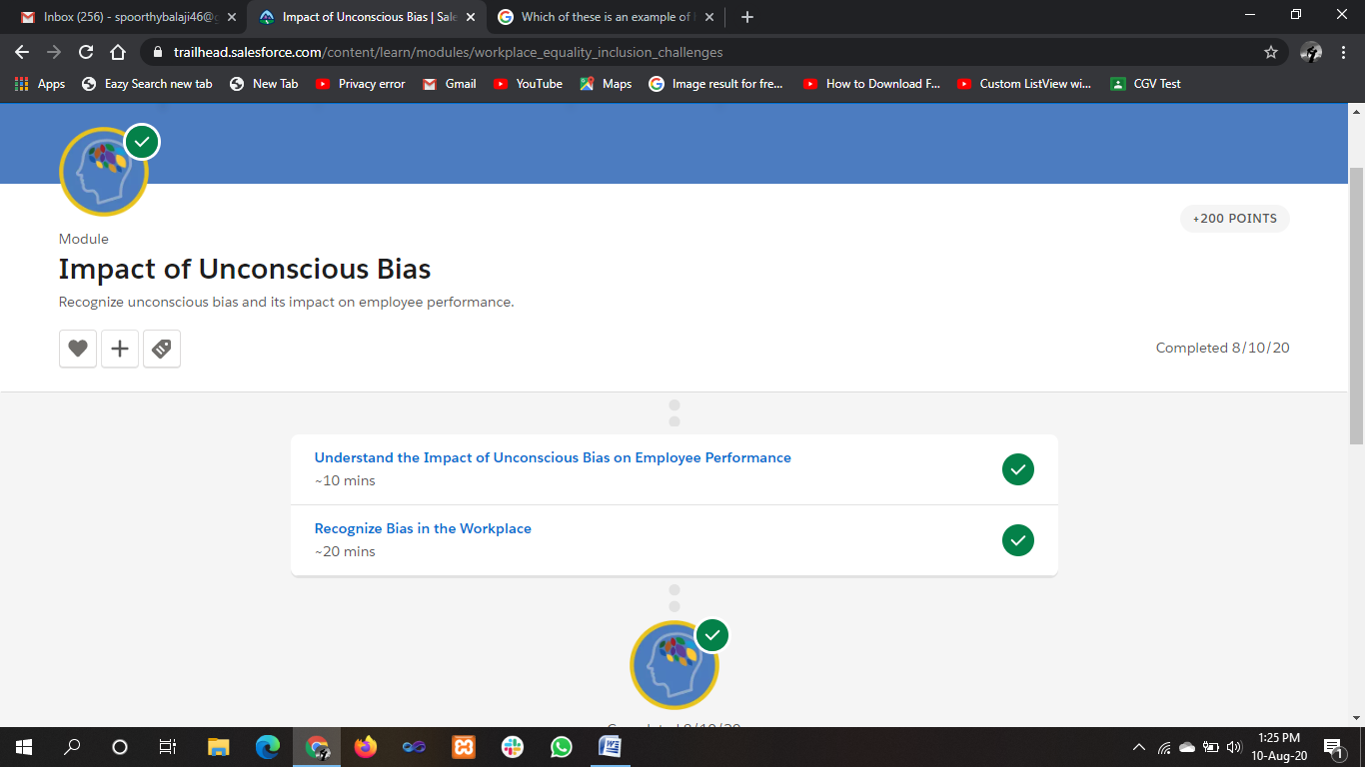

**ONLINE** **CODING**

**Check whether a number has consecutive 0’s in the given base or not**

**def floatoctal_convert(my_number, places = 3):**

**my_whole, my_dec = str(my_number).split(".")**

**my_whole = int(my_whole)**

**my_dec = int (my_dec)**

**res = bin(my_whole).lstrip("0b") + "."**

**for x in range(places):**

**my_whole, my_dec = str((my_decimal_converter(my_dec)) * 8).split(".")**

**my_dec = int(my_dec)**

**res += my_whole**

**return res**

**def my_decimal_converter(num):**

**while num > 1:**

**num /= 10**

**return num**

**n = input("Enter floating point value : \n")**

**p = int(input("Enter the number of decimal places of the result : \n"))**

**print(floatoctal_convert(n, places = p))**

